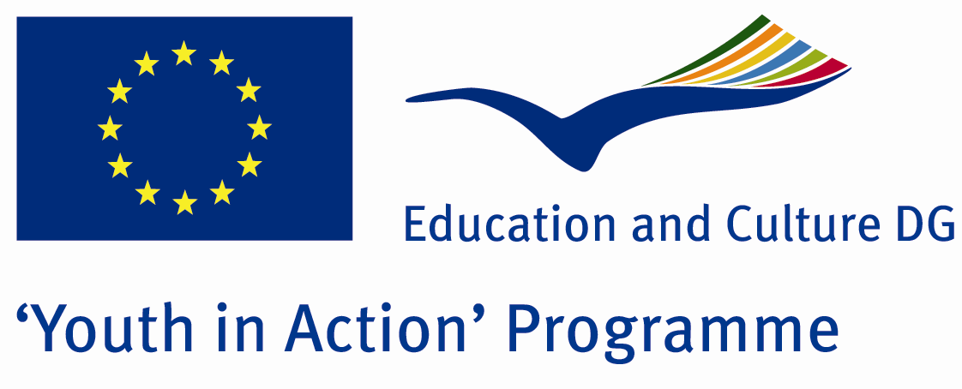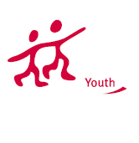

Action 4.3
Project Summary; The best of art is made by porcelain. In the city which has the most porcelain productivity of all after Italy, not only you will have the chance to recognise how a raw material becomes a porcelain but also you will have various ideas about the marketing. This is a unique opportunity for whom deal with marketing and art.

Project Title; Porcelain Art and Marketing
Date and Venue ; 01-07 July Turkey
Place: Kütahya.

Target Group ; Municipalities, City Councils and Non-Governmental organizations,
youth groups,culture and art groups,e.t.c

Participants ; 5 people from each country (over 18 -25 ). Totally 8 countries.

Conditions ; Accommodation, board and programme costs will be financed through European Commission Youth in Action Programme . Travel costs will be reimbursed in 70% (APEX Tarrifs). Organizations from all 27 EU member countries plus Liechtenstein , Norway and Iceland are eligible to take part.

Working language: English

Organisator group: Kutahya Education Council

How to apply: If you are interested, please send your Part III forms to
by e-mail please (in word file). Scan Part3 format is enough for application.(Fulfilled Part III which you can find in the attachment, of course signed and stamped) ..

Contact e-mail: anatoliaporcelainart@gmail.com

